Updating Your Profile Information in the RISe System

- Begin by clicking on your name at the top right corner and select “My Profile” option

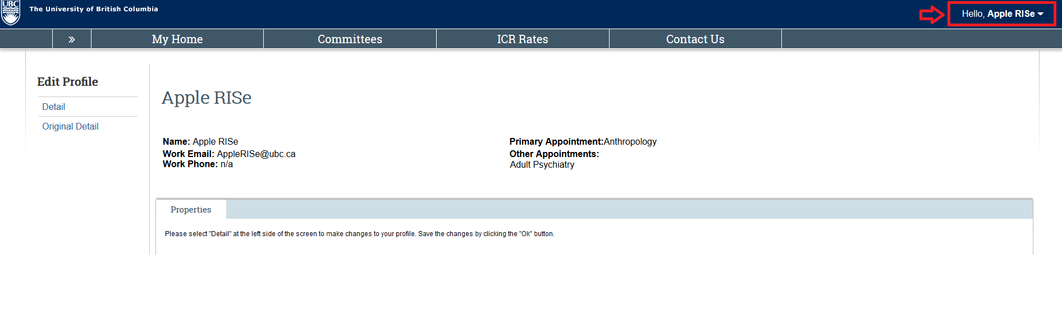
- Within your profile click on “Detail” to make edits to your profile
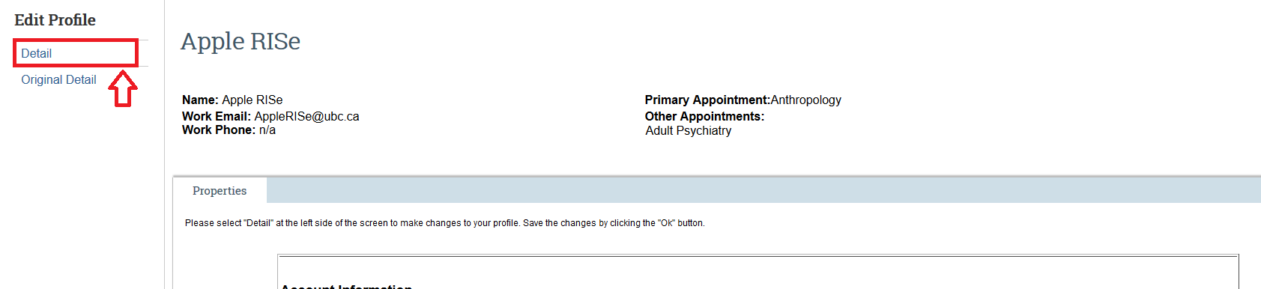

- UBC HR specific positions are automatically assigned by Workday and cannot be updated in RISe.
  - To have this information updated, please contact the UBC Integrated Service Centre (https://isc.ubc.ca/)

- For all Additional UBC and Non-UBC positions/affiliations.
  - If you are not affiliated with UBC or not in the UBC WD system yet, you can add your additional appointment(s) here.
  - To add a new position:
    - Hit +Add button
    - Fill in the form from the pop-up Window
    - Hit OK within the pop-up window
    - Be sure to hit OK again on the top right corner to Save

- To update an existing position
  - Hit “Update” next to your existing position
  - Edit the form from the pop-up Window
  - Hit OK
  - Be sure to hit OK again on the top right corner to Save

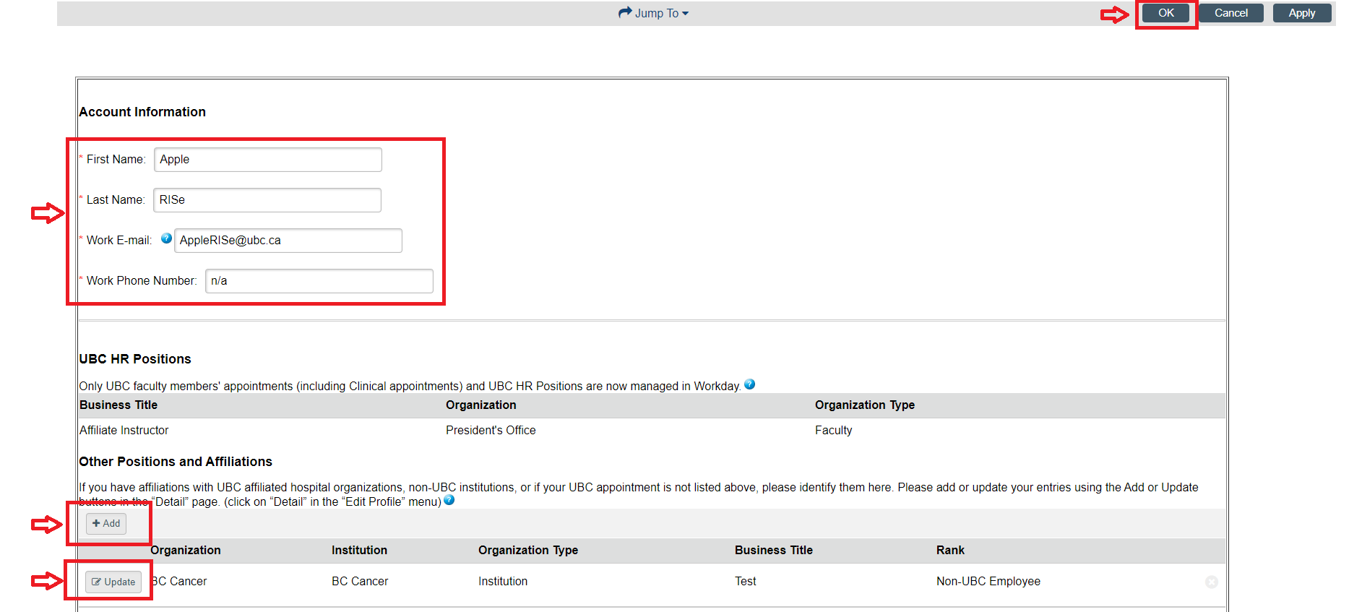
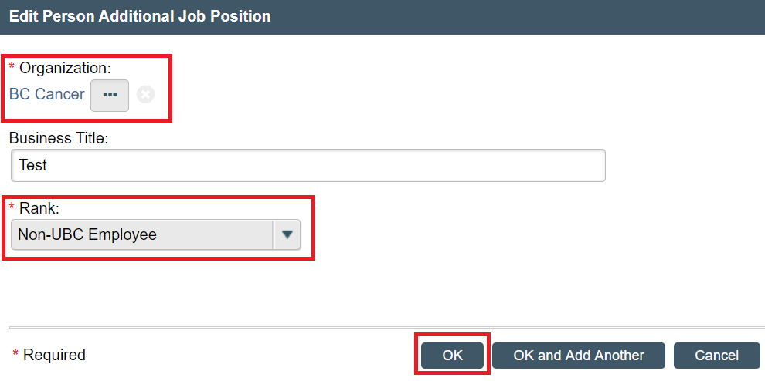
- When your profile edits are saved, click on “My Home” tab on the left hand side, to access your RISe home page where you will find options for your desired next activity in the system

