**REB EXCHANGE – REBX for UBC, UCalgary and UAlberta – June 2024**

**REBX Add Participating Sites Activity for UBC PI and Study Team with Online Access**

The Study PI and Study Team with online access now have a new activity called “Add Participating Sites” for any approved study in RISe. Currently, this activity is available for studies where the Board of Record (BoR) is one of the following UBC REBs: BREB, CREB, PHC, or UBC-Okanagan BREB.

Note: If the “Add Participating Sites” activity is not immediately visible, please refresh the page. In rare instances, you may need to clear your computer's cache.

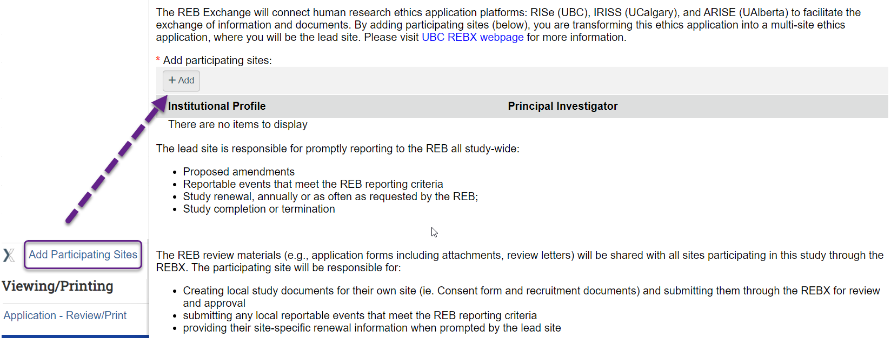

The Study PI and Team will need to complete two fields: Institutional Profile and Participating Site PI

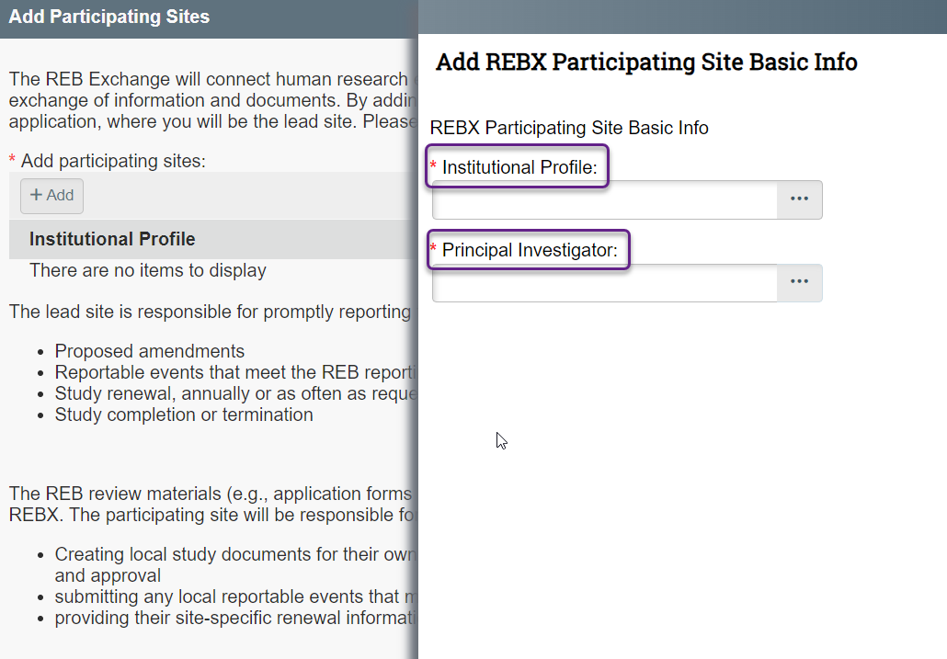

University of Alberta has 7 institutional profiles and University of Calgary has 6 institutional profiles

Note: You may need to scroll down to see full list for UCalgary

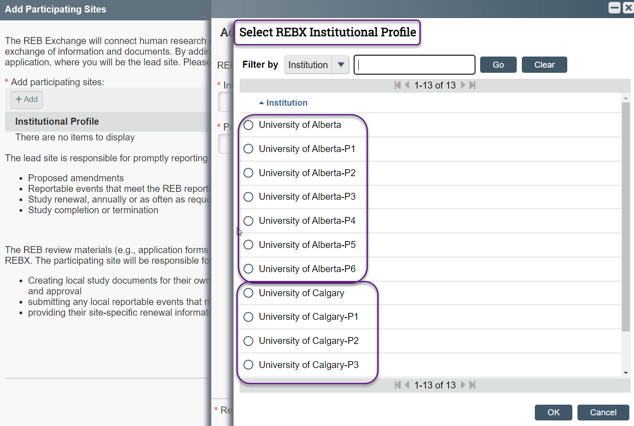

Select a person using one of the four available filters

Note: Advanced filter can be used for faster selection (e.g., last name and email address)

If you cannot find the person you are looking for on the list, please contact [risesupport@ors.ubc.ca](mailto:risesupport@ors.ubc.ca)

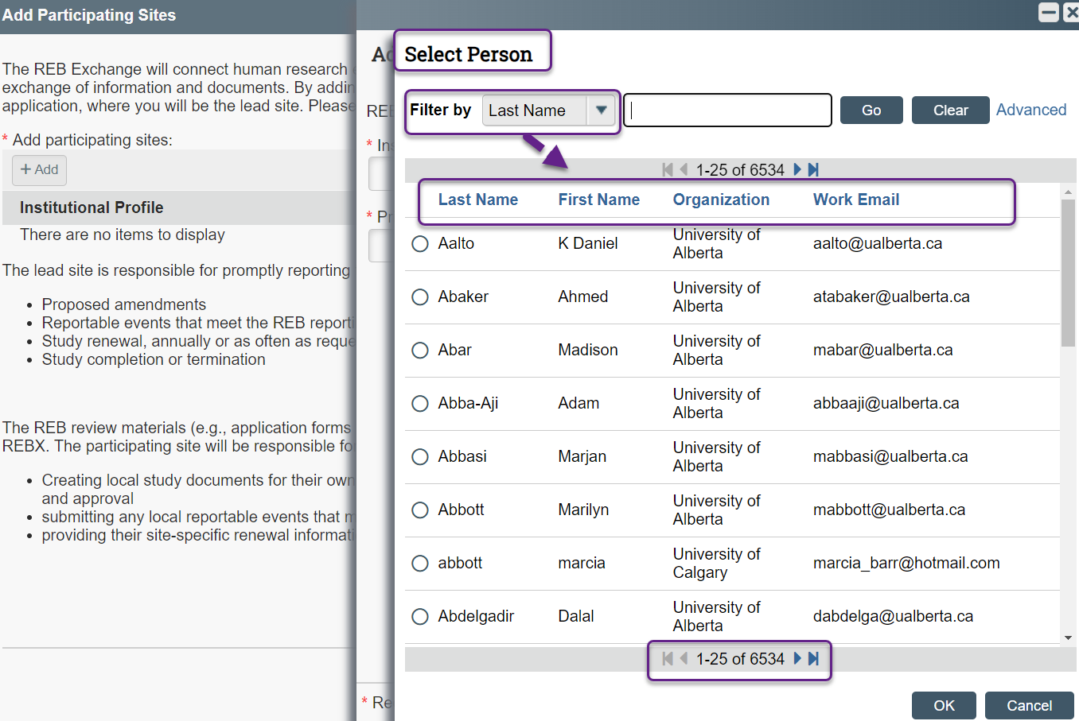

Multiple Institutions and PIs can be selected using the same “Add Participating Site” activity.

Note I: Before submitting the invitation, please review selected information and in case of error update or remove the selected information

Note II: Unique Institutional profile (e.g., University of Alberta-P1) can be added only once per study

